Born: 193
Gender: Male
Migration date: midspring 230

Personality:
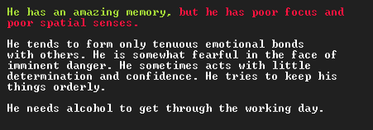
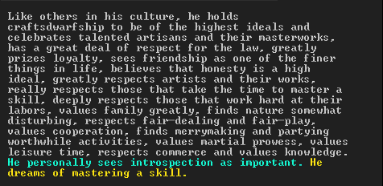
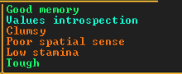

Position:
Baron of Howlmetal, following the death of his mother

Relationships:
Married to Urvad Canyonmurder in 226, who died in 229
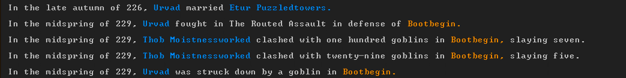
Mother – Ingiz Ringconfined, died in 230 in Bootbegin
Father – Ral Cloisteredlivid, alive, probably at Whitelash
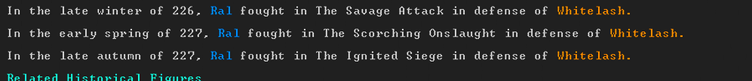
Lover – Edzul Anviltrampled, gay (double male) lovers since 211, both lovers got married with different partners in 226, and Edzul still has a wife


